Capston Project

The Battle of the Neighbourhoods 14. 07.2020

Chicago Crime Rate

REPORT

In this report I will explain and analyze Chicago crime rate and Socioeconomic factors and indicators, it will consist of:

1. Introduction section
2. Methodology section
3. Result section
4. Discussion section
5. Conclusion section

Introduction section

The relationship between socioeconomic status and crime is an important topic for public policy. In this project, we conducted a statistical analysis using data from the City of Chicago to explore the potential correlation between different dimensions of socioeconomic status and crime rates at the community-level. By running a series of regressions, we found obvious correlations between them, and among the seven selected socioeconomic indicators, the crowded housing rate and the unemployment rate seems to matter more than the others.

Methodology

In 2016, the city saw a dramatic spike in violent crime rates, with more than 760 reported homicides—up 42 percent from the previous year. Meanwhile, non-gun homicides and other crimes staying relatively constant.

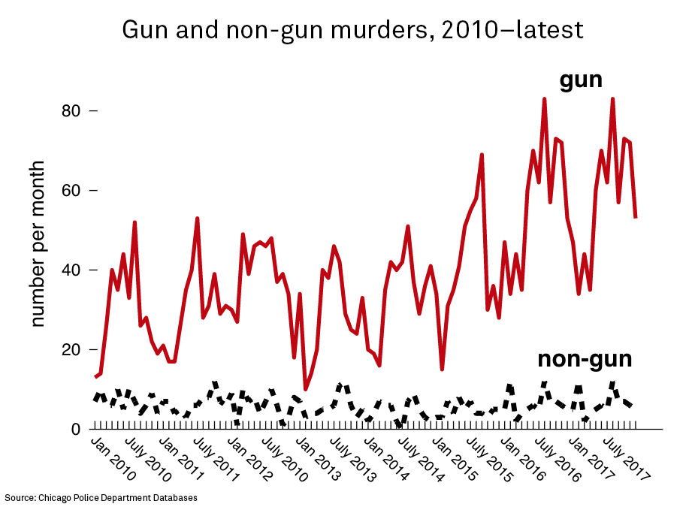

The violence was also extremely concentrated. 50 percent of all the shootings in 2016 occurred in just [a handful of neighborhoods](https://www.ipr.northwestern.edu/news/2018/images/skogan-shooting-map.png), including Austin, Garfield Park, North and South Lawndale, Englewood, and West Pullman. The crime is even more concentrated in those communities, often occurring within just a few blocks. There is one four-by-four block area in Humboldt Park, that has been in the top 5 percent of shootings in the city every year for 27 years.

“The most disturbing feature of the 2016 spike is that police is not catching anybody,” noting that the ability of Chicago police to solve gun violence has plummeted to single digits. Because crimes have gone unsolved, the standard model of policing—in which the police receive a call, investigate, and arrest someone—has collapsed. As a result, the ability to deter crime has plummeted, and people protect themselves by carrying a weapon, adding more guns on the streets and encouraging retaliatory violence.

There is a chance the crime spike may be disappearing, as homicides and shootings dropped in 2017.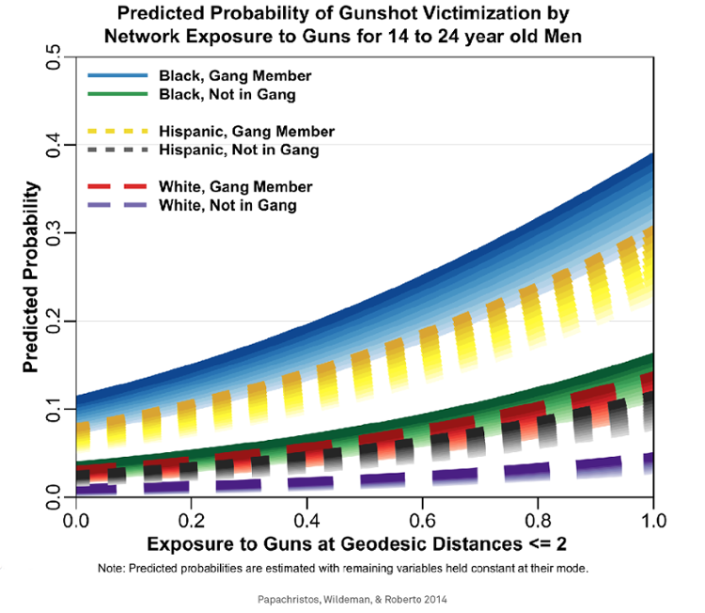

**Result Section:**

One way to understand the violence is by examining the way people—particularly young people—think. While some argue that crimes are carried out by people who seek to break the law and who are hard to deter. many crimes come down to the way people think and respond to situations. He described two different ways of thinking: automatic thinking and reflective thinking.

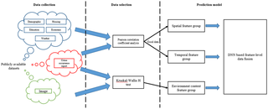A feature-level data fusion method with environmental context based on a deep neural network (DNN). Next dataset consists of data collected from various online databases of crime statistics, demographic and meteorological data, and images in Chicago, Illinois. Prior to generating training data, crime-related data by conducting statistical analyses. DNN which consists of the following four kinds of layers:

Type of Crimes in Chicago by 2014.

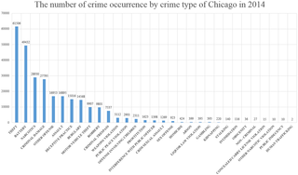

we want to see is the homicide crime distribution for the whole city grouped by police districts.

*# plot all homicides in dataset by location per District*df_homicide = df_homicide.loc[(df_homicide['X Coordinate']!=0)]sns.lmplot('X Coordinate',  
 'Y Coordinate',  
 data=df_homicide[:],  
 fit_reg=**False**,   
 hue="District",   
 palette='Dark2',  
 size=12,  
 ci=2,  
 scatter_kws={"marker": "D",   
 "s": 10})   
ax = plt.gca()  
ax.set_title("All Homicides (2001-2018) per District")

Image for post

* high homicide rates are clustered on the top left and middle bottom of the scatter plot.
* homicide rates in the top right and some areas in the middle are more freely scattered.

Now we are going to see yearly homicide rate:

*# plot bar chart of homicide rates for all years*plt.figure(figsize=(12,6))  
sns.barplot(x='Year',  
 y='HOMICIDE',  
 data=df_homicide.groupby(['Year'])['Primary Type'].value_counts().\  
 unstack().reset_index(),  
 color='steelblue').\  
 set_title("CHICAGO MURDER RATES: 2001 - 2018")

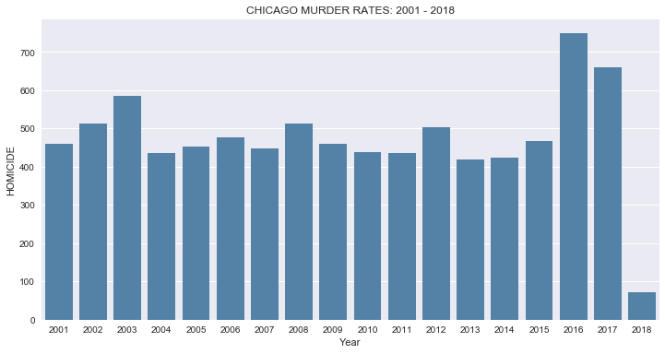

**Monthly Homicide Rates :**

*# plot homicides sorted by month*fig, ax = plt.subplots(figsize=(14,6))  
month_nms = ['January','February','March','April','May','June','July','August'\  
 ,'September','October','November','December']   
fig = sns.barplot(x='Month',  
 y='HOMICIDE',  
 data=df_homicide.groupby(['Year','Month'])['Primary Type'].\  
 value_counts().unstack().reset_index(),  
 color='#808080')  
ax.set_xticklabels(month_nms)  
plt.title("CHICAGO MURDER RATES by MONTH -- All Years")*# -------------------------------------------# plot average monthly temps in Chicago*  
*# source of data: ncdc.noaa.gov*mntemp = [26.5,31,39.5,49.5,59.5,70,76,75.5,68,56,44,32]  
df_temps = pd.DataFrame(list(zip(month_nms,mntemp)),  
 columns=['Month','AVERAGE TEMPERATURE'])  
fig, ax = plt.subplots(figsize=(14,6))  
sns.barplot(x='Month', y='AVERAGE TEMPERATURE', data=df_temps,color='steelblue')

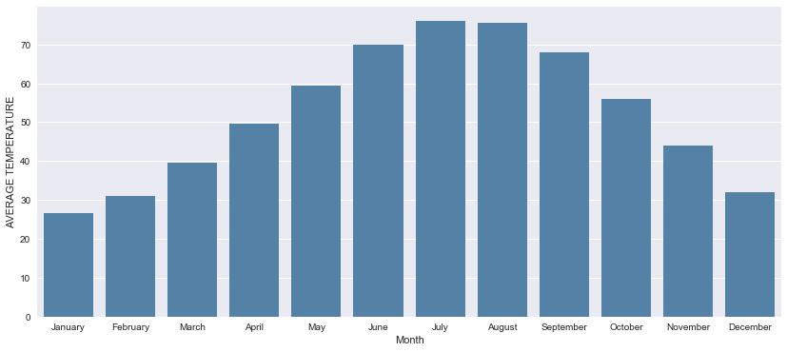

**Heat Map — Homicide Rates per Police District :**

*# create a heatmap showing crime by district by year*corr = df_homicide.groupby(['District','Year']).count().Date.unstack()  
fig, ax = plt.subplots(figsize=(15,13))  
sns.set(font_scale=1.0)  
sns.heatmap(corr.dropna(axis=1),  
 annot=**True**,  
 linewidths=0.2,  
 cmap='Blues',  
 robust=**True**,  
 cbar_kws={'label': 'HOMICIDES'})  
plt.title('HOMICIDE vs DISTRICT vs YEAR')

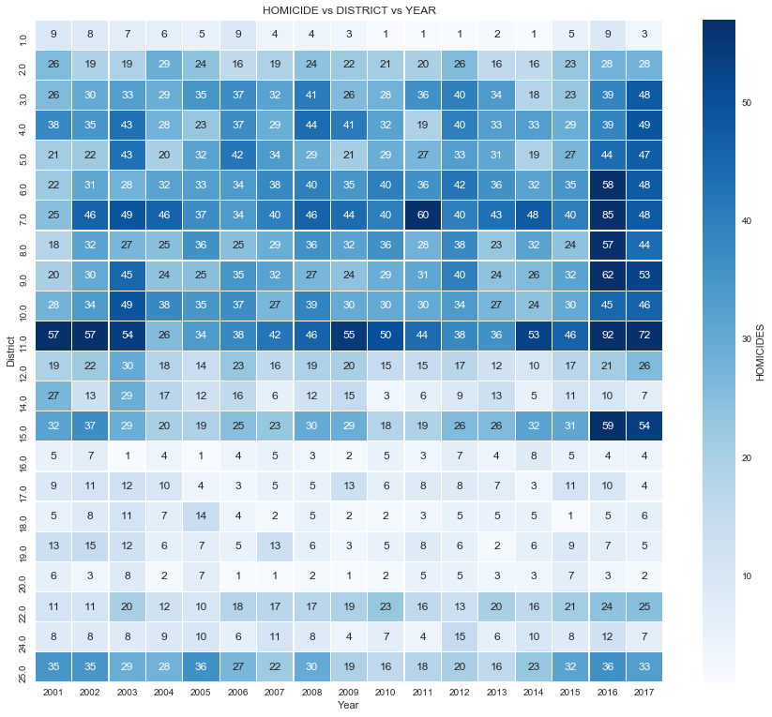

## Heat Map of Homicide vs District — (2016–2017)

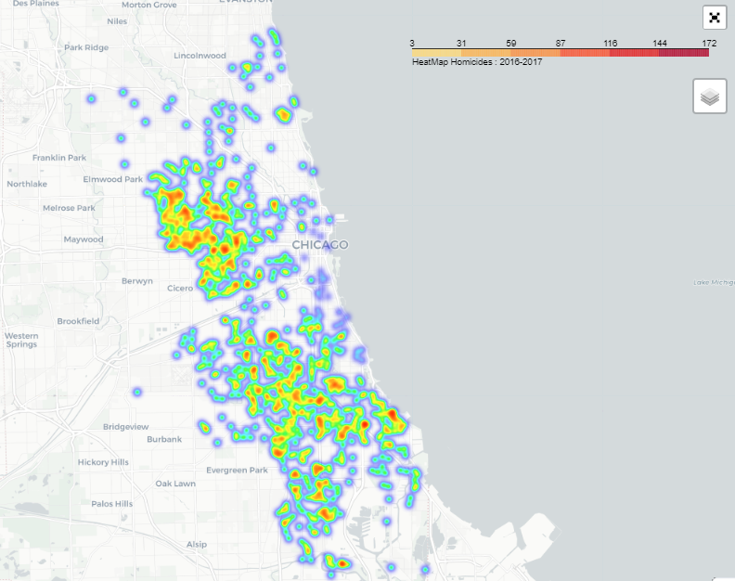

Conclusion

High rates of neighborhood violent crime are a serious problem for many Chicago Public School students and youth across the country. These findings underscore the potential for a lag between changes in the social environment and changes in behavior and learning. Despite dramatically declining crime rates in most cities nation,it may take years before the full benefits of relative safety are evident in local children’s academic achievement. Nevertheless, if reducing violent crime can improve students’ learning, even a little, then a substantial improvement in safety in the city’s most dangerous neighborhoods could not only improve the quality of life in those areas, but may have long-term benefits for the overall public school system as well.

Sources used:

<https://www.ncbi.nlm.nih.gov/pmc/articles/PMC5678996/>

[www.wikipedia.com](http://www.wikipedia.com)

https://data.cityofchicago.org/Public-Safety/Crimes-2001-to-Present/ijzp-q8t2